Help Needed from Members!
- Recruit new members – spread the word and get your colleagues to join the IOP and SWEC.
- Get involved.
- Tell us about your research interests – we want to hear from you at swec@physics.org

Welcome
Welcome to the inaugural newsletter for the Shock Wave and Extreme Conditions (SWEC) Group. SWEC brings together parties from both industry and academia with a common interest in novel aspects of high strain-rate and pressure phenomena. This interest encompasses a wide range of disciplines from energetic material behaviour through bio-materials to phenomena such as crash-worthiness of structures. Areas of particular interest include both the fundamental principles behind, and experimental techniques involved in accessing:
- Static high pressures, shock waves, blast and energetic materials
- Materials characterization across a range of strain rates
- High pressure or high-rate Materials Synthesis
- Development of equations of state and constitutive models
- The effects of high energy and high-rate energy deposition
- High-speed transient phenomena
- Pressure, energy, temperature and very high strain-rate response materials ranging from biological, soft systems to dislocation behaviour in single crystals.
SWEC seeks to facilitate research and discussion in these fields and to initiate and develop links between physicists and other researchers in this multi-disciplinary area. To this end, the group is open to / actively exploring collaborations with other interested parties. Let us have your ideas for future content.
Gareth Appleby-Thomas

Welcome to SWEC

SWEC Group Committee
Meet the Committee

Group Essay Prizes

IOP Joint Group Meetings

Group Sponsored Events

Events Diary

Contents
Studying the fascinating world of the behaviour of materials outside of the everyday.

SWEC
SHOCK WAVES AND EXTREME CONDITIONS

Issue #1, JUNE 2019

26th International Symposium on Ballistics

A Great Success!

The SWEC Group Committee
The current SWEC Committee members are:
Gareth Appleby-Thomas | Cranfield University | Chair
Ian Cullis | QinetiQ | Treasurer
Glenn Whiteman | AWE | Secretary
James Perry | University of Cambridge | Early Careers
Chris Braithwaite | University of Cambridge
Kate Brown | University of Cambridge | Equality Diversity and Inclusion
Mark Collinson | AWE | Database management
Craig Hoing | MOD
John Proctor | University of Salford
Bill Proud | Imperial College
Meet the Committee
The committee members’ scientific interests are wide ranging:
Gareth oversees a high strain-rate and ballistic impact research facility involved in both armour development and experimental shock physics. This work covers materials from metals to energetics, along with and the design of instrumentation, with a particular interest in single and two stage gas guns.
Ian develops numerical simulation methods to study dynamic processes including high velocity impact, penetration, explosion mechanics and energetic materials. This includes the integration of simulations with experiments.
Glenn is predominantly interested in shock physics and dynamic material strength. This includes the investigation of the response of many materials across a wide range of loading conditions, particularly the microstructural features responsible for macroscopic response.
James works on the high-rate dynamic properties of materials - particularly structural composites, energetics, metals and granular materials. His work is experimentally led, designing novel techniques to help understand the mesoscale phenomena controlling deformation and fracture processes.
Chris is an experimentalist engaged in research into the mechanical and dynamic behaviour of a wide range of materials, with a strong interest in granular and geological materials and specifically the influence of micro and meso structure on the bulk macroscale properties.
Kate’s interests include understanding the structural basis of damage resistance and mechanical failure mechanisms in soft and natural biomaterials. She is also involved in developing new experimental models of damage and infection in soft tissues using culture-based systems.
Mark studies the dynamic response of materials to shock loading, focusing primarily on providing experimental data in support of equation of state models. He uses gas guns to provide planar, 1D mechanisms for shock loading samples. In addition, he has an interest in the development of new diagnostics and experimental techniques, including pyrometry (temperature measurement) and sound velocity measurements at pressure.
Craig works in defence with specific interests in the effects of explosions on structures and materials, including fragmentation and structural design to contain these effects.
John’s research interests are concerned with the properties of liquids at high pressures and the development of material models to describe this behaviour.
Bill is interested in experimental shock physics and is currently working on understanding blast injuries and the shock properties of a wide range of materials.
If you are interested in working with the committee or becoming a future member, please let Glenn know by emailing swec@physics.org.
Group essay prizes

The committee is exploring ideas to award prizes for essays, research theses and journal papers on a topic related to SWEC. We are currently developing a detailed plan regarding targeting, aims etc.
For the inaugural year we are restricting the prize to undergraduate level and are identifying topics. If you have any ideas, we would like to hear from you. We will be making an announcement in the very near future.

IOP Joint group meetings
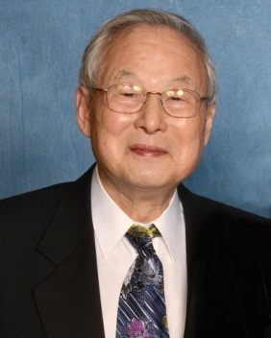
As you might expect there is potential common ground between the various groups in the IOP. The Officers of the group attend regular Group meetings held by the IOP. At the July meeting last year our Chair gave a short presentation on the SWEC group activities and goals. Several other Groups showed interest in some joint events/interactions, including Women in Physics, Early Career Members, Computational Physics, History of Physics, Physics in Food Manufacturing, Materials and Characterization, Plasma Physics and Vacuum.
We have identified three groups for our initial interactions:
- History in Physics: several potential topics of interest have been identified, most obviously an exploration of the history of shock/Extreme Conditions Physics.
- Physics in Foods: The physics involved in food processing is fascinating and varied; we share interests in the physics of materials, for example – from heating of polymers to processing of grains.
- Materials & Characterization: an important interaction, given our common needs for material properties and understanding.
We are aiming to organise between 1 and 3 events each year. Watch out for our calling notices!
Group sponsored events
The committee are keen to sponsor meetings related to the SWEC area. For example, SWEC sponsored the “Dislocations and High Rate Properties of Materials” event, which was held in Cambridge in July last year. The event was organised by Stephen Walley, (University of Cambridge) with approximately 25 attendees; a good size for open technical discussions.
Watch out for future events on the IOP and SWEC calendars.
Early careers
James: As the 'early career' member of the committee, I'm looking at ways to help support PhD students, postdocs and recent graduates in industry from across the SWEC community. We are all very busy, and I don't want to add unnecessary repetition to your conference diaries, but I feel that a carefully targeted early career event might be of some benefit – such as an informal, one-day seminar of quick-fire presentations and networking. The first step is to find out who you are and gauge levels of interest, and I need express permission to use your contact details for particular purposes. As such, if you might be interested then please email me at jip24@cam.ac.uk (with "SWEC EC" in the subject line) and confirm that you would like to be included in discussions of SWEC-specific early-career events.
Any thoughts and suggestions for activities would also be very welcome, and if you're keen to get involved in organising things then please let me know!
Case study – Shock response of biological materials
As an example of the diversity of research within the SWEC community, a recent project at Cranfield University (resulting in a successful defence of a PhD thesis entitled “On the shock response of biomaterials”¹ by Brianna Fiztmaurice, an IOP member and student of the committee chair, Gareth Appleby-Thomas) was focused on the unusual area of ‘panspermia’ – namely the potential to translate biological life from one planetary body to another. This work, building on a previous PhD (James Leighs) involved development of a novel capsule configuration designed to allow quasi-1D loading and recovery of biological samples using single-stage gas-guns. Investigation into the shock response of Escherichia coli and Saccharomyces cerevisiae found differing cut-offs in the effect of shock on the growth rates. This result was tentatively attributed to the complexity of the E. coli cell envelope vs the S. cerevisiae cell membrane.
Left: experimental setup; Right: Comparison of growth-rates for shocked / recovered samples of Escherichia coli and Saccharomyces cerevisiae.
1. Fitzmaurice B. C., Painter J. D., Appleby-Thomas G. J., Wood D. C., Hazel R., McMillan P. F. (2017). On the response of Escherichia coli to high rates of deformation, Shock Compression of Condensed Matter 2015, AIP Conf. Proc., Vol. 1793, 140002 1-5.
If you have a case study you would like to publish in future newsletters, then please let us know at swec@physics.org.

Events diary
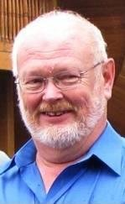
The Student award provides conference registration and travel support to selected students for attendance at the International Symposiums on Ballistics. This award has been attributed to:
Cyril Robbe
Timo Sailaranta
Heath Martin
Alon Weiss
Roman Kostiski
All information to know how to submit for nominations for the Atlanta symposium can be found at:
http://www.ballistics.org/student_awards.php
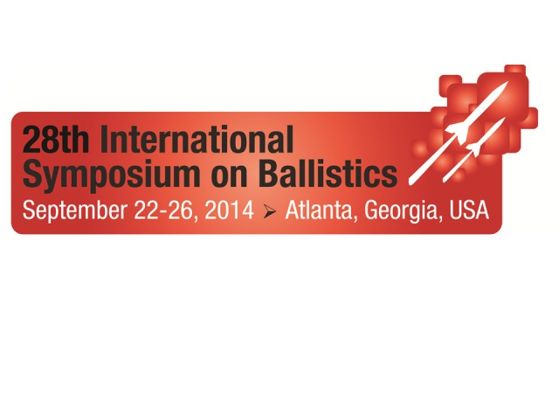
These are some of the relevant forthcoming conferences and meetings that are pertinent to the interests of SWEC members.
Dates | Event | Location | Website | Notes
16- 21 June  2019 | APS SCCM | Portland, OR, USA | https://www.aps.org/units/gsccm/meetings/annual/ | Early Reg. Deadline - 17/05/19
2-5 July  2019 | ISIE | Gmunden, Austria | https://www.jku.at/institut-fuer-polymer-product-engineering/news-events/konferenzen/isie-2019/ | Early Reg. Deadline - 31/03/19
4-9  August  2019 | AIRAPT | Rio De Janeiro  Brasil | http://www.airapt.org/ | Early Reg. Deadline - 3/06/19
18-22  August  2019 | PRICM | Xian, China | http://www.medmeeting.org/7482?lang=en | Early Reg. Deadline - 15/06/19
1-6 September  2019 | EHPRG | Prague  Czechia | https://ehprg2019.org/ | Early Reg. Deadline - 31/05/19
13-16  October  2019 | 13th PEP | Beijing  China | http://www.iaspep.com.cn | Abstract Deadline  1/08/19  Early Reg. Deadline  10/7/19
4-8  November  2019 | 31st ISB | Hyderabad  India | http://www.ballistics.org | Early Reg. Deadline  31/8/19
23-27  February  2020 | TMS | San Diego, CA, USA | https://www.tms.org/tms2020
23-26  June  2020 | ICILSM | Trondheim, Norway | https://www.ntnu.edu/icilsm2020 | Abstract Deadline - 01/02/20 Early Reg. Deadline - 01/04/20
 | NMH 2020 | Montenegro

If you have any additional events to add to the diary, then please let us know at swec@physics.org.

